**Hello World RESTful Web Service**

Write a REST service in the spring learn application created earlier, that returns the text "Hello World!!" using Spring Web Framework. Refer details below:

**HelloController.java:**

package com.cognizant.spring_learn.controller;

import org.slf4j.Logger;

import org.slf4j.LoggerFactory;

import org.springframework.web.bind.annotation.GetMapping;

import org.springframework.web.bind.annotation.RestController;

*@RestController*

public class HelloController {

private static final Logger ***LOGGER*** = LoggerFactory.*getLogger*(HelloController.class);

*@GetMapping*("/hello")

public String sayHello() {

***LOGGER***.info("START - sayHello()");

***LOGGER***.info("END - sayHello()");

return "Hello World!!";

}

}

**application.properties:**

server.port=8083

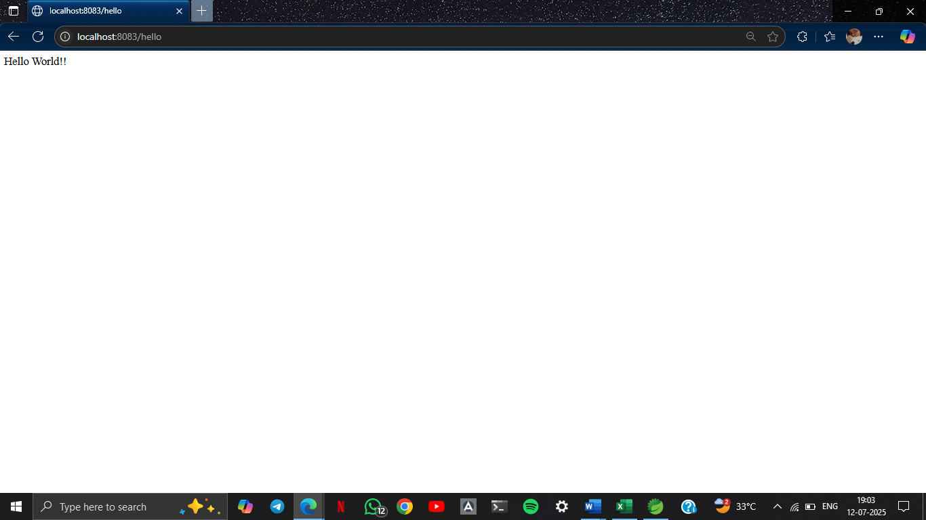

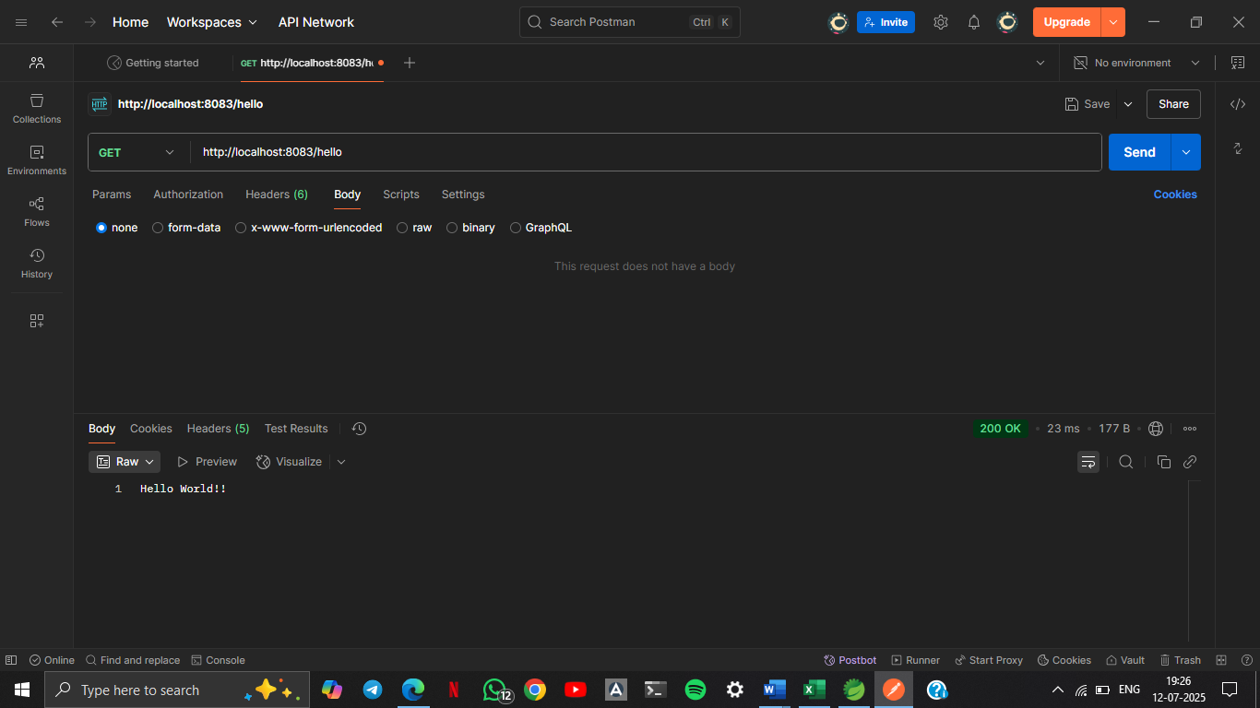

**SME to explain the following aspects:**

* In network tab of developer tools show the HTTP header details received

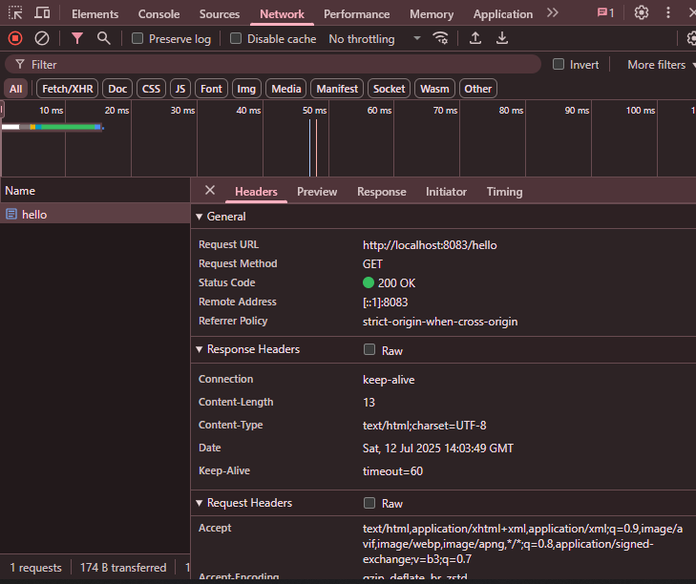

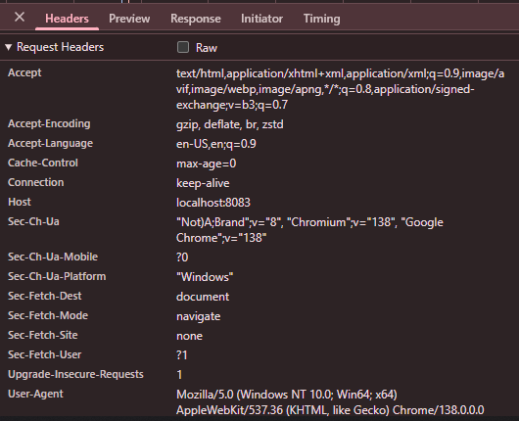

* In postman click on "Headers" tab to view the HTTP header details received

